SESSION 1, Overview of Diabetes
Objective measure of mastery: patient/family is able to: | Content | Methods | “Spot Checks”
- State why blood sugar goes high in type 2 diabetes.  - State what causes type 2 diabetes  - State that the treatment changes as the problems of type 2 diabetes changes | What is Diabetes?  A. Diabetes happens when the body can not turn food  into energy.  B. Normal metabolism  1. Food changes into sugar (glucose) – the main fuel source for the body.  2. Sugar gets into the blood stream and the amount of sugar rises.  3. A message is sent to the pancreas to make insulin  4. Insulin travels to the cells (muscle). Insulin is the key to open the doors in the cell.  5. Sugar then enters the cell, the blood sugar returns to normal and energy happens in the cell.  6. Normal blood sugar is 70-130 mg/dl; goal for the TODAY trial is 70-150 mg/dl.  C. Type 1 diabetes  1. Happens in children.  2. The body stops making enough insulin.  3. The cells still have enough doors.  4. People with type 1 diabetes must take insulin shots to stay alive and healthy.  D. Type 2  1. Happens in adults and some children.  2. At first, the cells do not enough doors or the doors just won’t open.  3. Later, the body stops making enough insulin.  4. People with type 2 diabetes use diet, exercise and medications to open the cell doors.  5. Later, people with type 2 diabetes may also need insulin.  E. Will type 2 diabetes go away?  1. It does not go away – may act differently at different times.  2. Progressive nature of type 2 diabetes (insulin resistance to beta  cell exhaustion).  F. What is insulin resistance ?  1. Basically, closed doors in the cell. The cell is resisting insulin.  2. Acanthosis nigricans (AN): dark skin patches on the neck, breasts, abdomen, knees, elbows, groin indicate insulin resistance.  3. AN will not go away with bleaching or scrubbing- may fade when the insulin resistance is treated.  G. Truth or fiction:  1. You get diabetes from eating too much sugar.  FICTION: Anyone can get diabetes. Type 2 diabetes can be  caused by eating too many calories and being overweight. Type 2 diabetes can be inherited.  2. Diabetes can be cured with herbs.  FICTION: There is no cure for diabetes right now. Some people  try herbs but these things do not make more insulin and they do  not open the cell doors.  3. My aunt takes insulin pills.  FICTION: The pills for diabetes are NOT insulin. The pills helps  open the doors. So far, there are no pills that replace the insulin  shots.  4. Type 2 diabetes is the mild form – you only have to take a pill!  FICTION: All types of diabetes are very serious. All types can  lead to bad health problems. High blood sugar is not healthy for  anyone!  H. Why worry about diabetes and high blood sugars  1. High blood sugars can make you feel tired, sleepy and thirsty.  2. High blood sugars can cause you to have to urinate more often.  3. High BG: you might be sick more often, have infections that won’t  heal.  4. Damage to important body parts – eyes, kidneys, heart, feet.  I. Balancing keeps BG in control.  1. Diabetes requires balancing those things that raise blood sugar  with those things that lower blood sugar.  2. Things that raise BG: food (especially carbohydrate), stress,  illness.  3. Things that lower BG: exercise, activity, medication (pills and  insulin).  J. How to take care of diabetes.  1. Eat healthy food.  2. Exercise and be active most days.  3. Take your diabetes medicines.  4. Check your blood sugar. | Patient Manual  Videos:  Felt board  Posters:  Pancreas  anatomy  What insulin does  Insulin and cell doors: normal  Insulin and cell doors: type 2 diabetes  The care for type 2 diabetes changes  Balance of food and meds/ activity | Child/ family are able to answer the following:  What is a normal blood sugar value ?  How does food provide  energy ?  What is diabetes ?  How long does a person have  diabetes ?  How does a person know he/she has diabetes ?  How does a person get diabetes ?  If blood sugars are running high, what things could be adjusted to better control the sugar ?  How will you describe diabetes to a family  member or friend ?

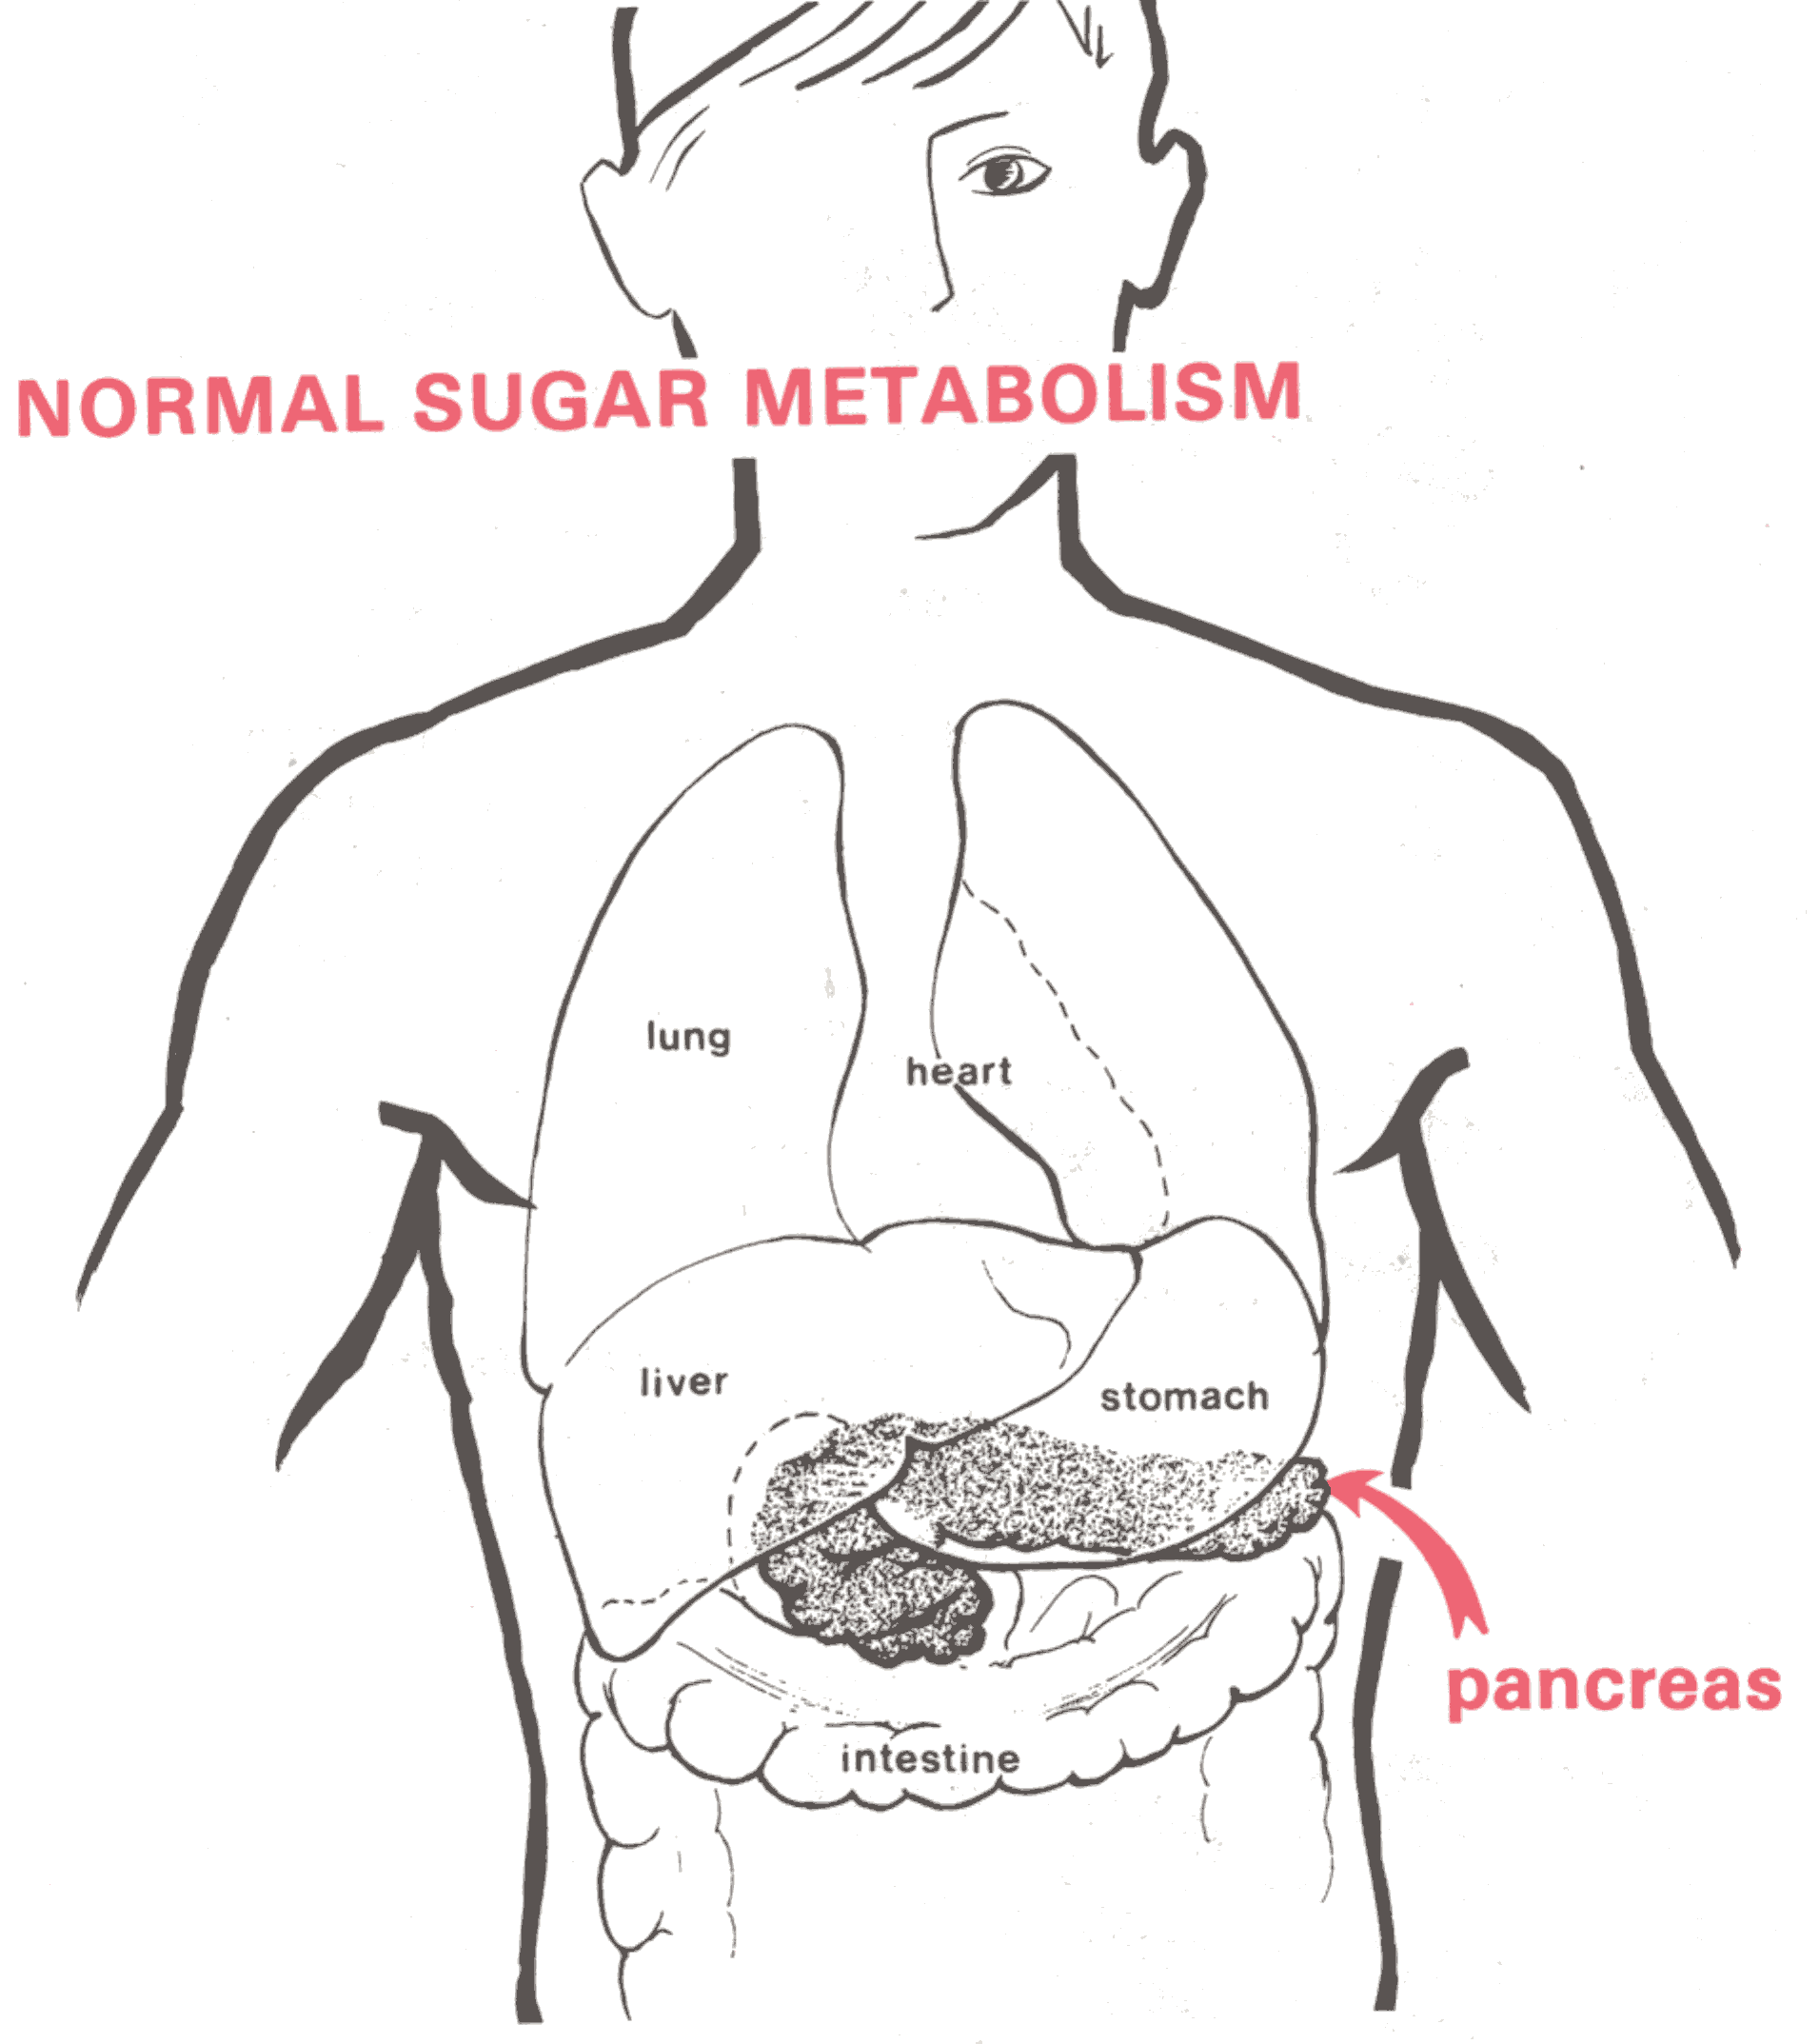
From Travis, L. An Instructional Aid for the child with Type 1 diabetes

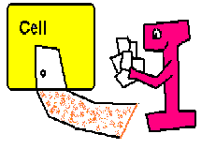
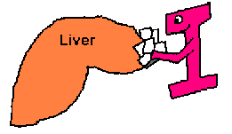
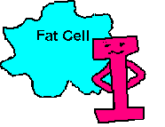
What insulin does

I
I
I
I

I
I
I
Cell Doors are closed
Type 2 Diabetes
I
I
I

The Care for Type 2 Diabetes Changes
Cell Doors are Closed
Insulin
Insulin
Tired pancreas
Diet
Exercise
Monitoring


Blood Sugar

How to use the Diabetes FeltBoard

What it is: The “Diabetes Felt Board” is a collection of cardboard pieces depicting important body parts involved in food metabolism.

How to use it: The board works for both children and adults, literate or not. Basically, the educator tells a story using the pieces.

The Diabetes FeltBoard can be used to teach:
- how food becomes glucose
- basic pathophysiology of type 1 and type 2 diabetes
- hypoglycemia and its counter-regulation
- hyperglycemia
- ketones source and treatment

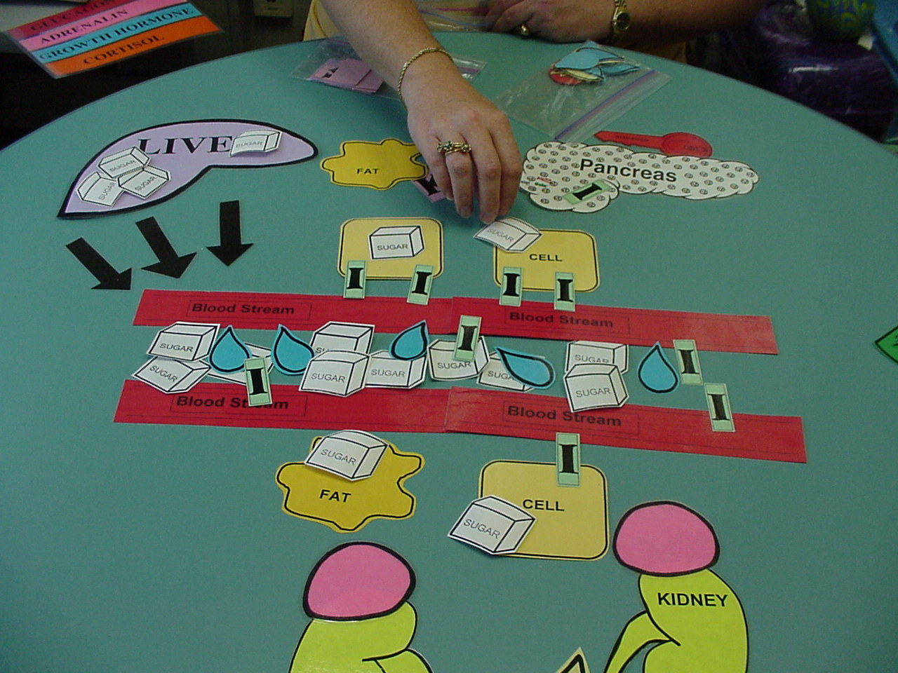
© B Schreiner, 1986, 2003
Using the Diabetes FeltBoard to teach how insulin works to lower blood glucose

1. Set up the environment. It could be an actual board covered with felt or just a table top. If you use a felt board, you will need to glue Velcro or sandpaper to the back of the pieces so they will stick.

2. Put out the following pieces:
blood stream
body cells
pancreas
liver
kidney
fat cells
ketones (the big purple “K”) – hide the “K” pieces under the fat cells
insulin (the big red “I”) – hide several “I” pieces under the pancreas

3. Have the following pieces in easy access:
sugar cubes
more insulin (“I” pieces)
water drops

4. Begin your story. Here is a sample.

STORY: How the body uses food for energy (normal metabolism)

What you say | What you do
Let’s talk about how your body uses the food you eat.  These red bars are the blood stream. The blood stream carries food to all parts of your body.  These are body cells. Body cells are small parts that make up your muscles and bones and skin and body parts. Body cells need sugar for energy. | Point to the blood stream. If needed, point to the veins on your hand to describe the blood stream.  Point to the body cells
The other body parts we will talk about are:  the pancreas  the liver  the kidney  We will talk about what these parts do in a minute. | Point to the felt board pieces.  Hold up the pancreas over your abdomen to show where the organ is located. Do the same with the liver.
When we eat, the food turns into sugar in the body. This sugar is called glucose. Glucose or sugar is the favorite food of the body cells. They must have sugar to work.  Sugar gets to the cells by taking a trip in the blood stream. | Place several sugar cube pieces in the blood stream.  (Don’t put any into the cells just yet.)
When sugar comes to a cell, it must enter through special doors (called insulin receptors).
These doors are locked. They will open only with a key called insulin.
The body makes insulin in the pancreas.  Insulin leaves the pancreas and travels with the sugar to the cells.  Insulin opens the door and builds a bridge for sugar to cross into the cell. Sugar goes into the cell. | Move insulin from the pancreas into the blood stream.  Then move insulin so that it makes a bridge from the blood stream into the cell.  Move sugar across the bridge into the cell.  Be sure to leave some sugar cubes in the blood stream.
QUESTION: Do you see what has happened to the amount of sugar in the blood stream ? | Encourage the learner to recognize that the blood sugar has returned to normal.
ADVANCED INFORMATION: We have seen one of the jobs of insulin. Insulin has 2 other jobs: putting sugar in the liver and protecting the fat cells.  When insulin is working well, it can store sugar in the liver. This is good for times when we skip a meal or can’t eat on time.  The sugar will be able to leave the liver and keep blood sugar normal.  Insulin also protects the fat cell by storing extra sugar there. This is good for when we are without food for very long periods of time. | Determine whether your learner needs this information or is ready for it. This information lays the foundation for a later discussions of hypoglycemia or ketones.  Move insulin to the liver – move sugar across the insulin bridge into the liver.  Move insulin to the edge of the fat cell.

SESSION 1, Simple Medical Nutrition Therapy
Objective measure of mastery: patient/family is able to: | Content | Methods | “Spot Checks”
- Select acceptable portions of food. | Simple steps for healthy eating: a basic introduction to healthy eating (session 2 will include more detail).  Until your next visit:  1. Avoid all sugar drinks.  a. Good picks: water; diet drinks; 100% fruit juice (limit  to 4-6 ounces per day); skim milk or 1 % milk.  b. Avoid: sport drinks; regular soda; fruit drinks.  2. When you eat – eat less.  a. Eat half of your usual meal.  b. Use a measuring cup.  c. Limit meat servings to the size of a deck of cards.  d. Use small zip bags to portion snacks.  e. Eat one sandwich instead of two.  f. Always leave something on your plate.  3. Don’t skip meals. Try eating 3 meals each day.  a. Eat breakfast.  b. Avoid eating late at night.  4. Use the food shopping list for healthy marketing ideas | Patient Manual  Refer to food shopping list  Videos  Posters | Child/ family are able to answer the following:  How will you limit the sports drinks, juices and regular sodas for the next week ?

SESSION 1, BG testing Skills
Objective measure of mastery: patient/family is able to: | Content | Methods | “Spot Checks”
- Perform BG test with acceptable skill.  - Complete a log book accurately.  - Use BG results to tell effect of activity and food. | A. Use of One Touch Ultra Smart.  1. Selecting sampling site (fingertips or alternate sites: palm of hand, forearm, abdomen, etc).  2. Care and handling of supplies: strips, control solution, lancets, lancing device, meter.  3. Obtaining adequate sample.  4. Operating meter to obtain BG result.  a. Setting date and time.  b. How to code the meter & importance of correct code.  c. If using alternate site, the child must select “Alternate Site” in the meter’s test mode.  5. Meter memory.  6. Frequency of testing: twice per day (before breakfast and one other time such as before supper or after lunch).  7. Meaning of BG results.  B. Completing the study log book.  1. How to record blood glucose values.  2. Recording medication use: check or circle the picture of tablets for each pill taken.  3. Recording activity: Circle the runner for each 30 minutes of physical activity; Circle the TV for each 10 minutes of sedentary activity (videogames, TV, computer).  4. Recording food intake.  a. Run-in: patient to record type, amount and time of meals and snacks.  b. Medication arms (after randomization): foods and activities not recorded.  5. Reinforce importance of bringing log and meter to EVERY visit.  C. Supplies.  1. What supplies are needed.  2. How to obtain supplies.  a. Supplies that are provided by the study.  b. Working with insurance plan.  c. Refer to social worker as needed.  3. Prescription. | Patient Manual  Videos  Posters  Fingertip: blood vessel  Log book  Other: One Touch Ultra Smart owner’s manual and quick start guide  MOP for detailed use of log books | Child/ family are able to answer the following  Where will you obtain  supplies ?  What would you do if you forgot to test one day ?  How will you remember to bring your log book and meter to the  visits ?

Blood vessel
Nerve endings

SESSION 1, Glycemic Targets
Objective measure of mastery: patient/family is able to: | Content | Methods | “Spot Checks”
- State goals of blood sugar are 70-150 and goals of a1c are less than 6%.  - State that the a1c measures the average blood sugar for the past 3 months. | Blood Glucose Targets  A. Keeping blood sugars in good control  1. Aim for 70 to 150 most of the time for fasting and < 200 mg/dl for 2 hour post prandial.  a. Best to have BG in the lower end of the target.  2. Too high: increases activity and eat less food.  3. Too low: treat immediately with carbohydrate (15 grams).  B. Hemoglobin A1c.  1. A blood test that averages the blood sugar for the past 3-4 months.  2. Non-diabetic normals: 4 to 6%.  3. Relationship of BG to A1c:  a. 6% is an average BG of about 135 mg/dl.  b. 8.5% is an average BG of about 222 mg/dl.  4. During the TODAY trial, patients and teams will not know the actual A1c value. They will be told if the number starts to get too high. | Patient Manual  Videos  Posters  Target  Target blood glucose levels (what to do) | Child/ family are able to answer the following:  What will you (your child) have to do to control blood glucose?  What are your BG goals?  If blood sugars are running high, what things could be adjusted to better control the sugar?

80-150
70-120
100-200

Target Blood Glucose

TARGET BLOOD GLUCOSE LEVELS
Goal: 70-80 % of blood sugars are within your target
TOO HIGH:
Use dose changing rules to
lower the BG

If HIGH with Moderate or
Large ketones, CALL your
diabetes team
IN TARGET !!!
No changes needed
TOO LOW
Treat immediately with
15 grams of carbohydrate

(1/2 cup juice or 4 ounces cola, or
6 roll candies or 1 Tbs sugar)

If lows are frequent, a dose
change is needed
Remember: Not every BG can be explained.
Don’t overreact to each BG. Look for patterns.

SESSION 2, Feelings and Diabetes
Objective measure of mastery: patient/family is able to: | Content | Methods | “Spot Checks”
- State that having negative feelings about diabetes is normal and can be shared with family, friends, and study teams. | FEELINGS AND LIFE WITH DIABETES  A. Feelings – what’s normal.  1. Diabetes hurts emotionally.  2. Common feelings include: anger, confusion, denial, guilt, fear, sadness, resentment, burnout.  3. Feelings may shift from day to day.  4. Sometimes our feelings are based on how we physically feel – sometimes on what the BG meter tells us!  B. What to do- emotional healing.  1. Learning to cope with disappointments, troubles is a normal part of life.  2. Find positive ways to deal with feelings- here are some ideas:  - Talk to a trusted friend or family member.  - Learn all you can about diabetes to better understand it.  - Talk with someone who has diabetes.  - Seek spiritual support.  - Take a walk.  - Give yourself credit for trying – mistakes are part of learning. | Patient Manual  Videos  Poster | Child/ family are able to answer the following:  How do you feel about having diabetes ?  (Parents): Do you worry about your other children getting diabetes ?  Have you spoken with other people who have diabetes ?

SESSION 2, Medications
Objective measure of mastery: patient/family is able to: | Content | Methods | “Spot Checks”
- State that type 2 diabetes is treated with pills and insulin (as well as activity and nutrition)  - State that diabetes pills are not insulin.  - State that metformin causes the body to use insulin better.  - State that metformin should be taken before meals.  - State what to do if a dose of metformin is missed. | Diabetes Medications  1. How pills work to control diabetes.  a. Pills are not insulin.  b. Pills make insulin work better (i.e., help to open the doors in the cells).  2. Metformin.  a. Helps to open cell doors.  b. Does not make more insulin in the body.  c. Lets the body use its own insulin better.  d. Must be taken with meals – take with breakfast and with supper.  e. Side effects.  1. Hypoglycemia – unusual – let the diabetes team know of any symptoms.  2. GI upset or diarrhea – could happen – let the diabetes team know about these symptoms.  3. Don’t stop the medicine if these symptoms are happening – let the team know – they will make suggestions about what to do.  3. What to do if dose missed.  a. If 1-2 hours after missed dose – take all of dose.  b. If longer than 2 hours – don’t take dose.  c. Never take the morning dose and the evening dose at the same time.  d. Tips to help remember:  - Sticky notes on the bathroom mirror.  - Reminders next to the meter.  - Calendar reminders.  - Parents remind.  e. Always record missed doses in the log book.  4. What to do for fasting.  a. Talk with the study team – doses may need to be adjusted.  b. Don’t stop a dose on your own.  c. Keep drinking plenty of water during the fast.  d. Add extra BG tests.  5. Will insulin ever be necessary?  a. Maybe – type 2 diabetes is progressive and the pancreas may stop making enough insulin.  b. Insulin is always used when activity, nutrition and medication approaches no longer keep BG in target. | Patient Manual  Videos  Poster  Morning and evening pills | Child/ family are able to answer the following:  How does metformin work to lower blood sugar?  Is metformin insulin?  What would you do if you missed a dose of your study medicines?  How will you remember to take your medicines?

Morning
2 pills
Evening
2 pills

SESSION 2, MNT: food types, CHO, pyramid, meal plan
Objective measure of mastery: patient/family is able to: | Content | Methods | “Spot Checks”
- Identify types of carbohydrates.  - State that foods high in fats and calories contribute to weight gain.  - Select nutritious foods lower in fat and calories for meals and snacks. | Nutrition Survival Skills  A. Nutrition Guidelines for Diabetes Management.  1. In previous meal planning approaches, the individual was  taught to avoid sugar and concentrated sweets.  2. New guidelines recognize that all sources of carbohydrate  (CHO) raise blood glucose about the same.  3. Goals of medical nutrition therapy and purpose of meal  planning:  a. Normalize blood glucose.  b. Normalize lipids.  c. Provide optimal nutrition for growth.  d. Achieve reasonable body weight.  B. How much food do you need?  1. Depends on age, activity level, growth, weight for age.  2. Calories are used to measure energy.  3. If there is more energy coming in (eating) than going out (exercise), the person will store the calories and gain weight.  4. Where do calories come from?  Carbohydrates  1. Nutrient that affects blood glucose the most.  2. Primary source of fuel and energy for the body.  3. Carbs come in healthy packages, full of vitamins and minerals (fruits, vegetables, milk, grains).  4. Carbs also come in unhealthy packages – full of fat and calories and not much vitamins (candy, snack foods).  Sugar and Sugar Substitutes  A. Can I eat sugar ?  1. A form of CHO – will raise BG.  2. Found in fruits and vegetables, honey, syrup, fructose, fruit juice.  3. Often seen on labels even if the food is not sweet.  4. Must be counted in the meal plan: Sugar is at the top of the  pyramid.  5. Sugar is a carb: sugar is found in many forms: table sugar, brown sugar, honey, maple syrup, corn syrup, fructose.  a. Sugar provides empty calories.  b. A 20 ounce soda has 16 teaspoons of sugar – enough to raise blood sugar 200 points!  B. Sugar substitutes.  1. Ok to use.  2. Types:  - Saccharin – pink package – “Sweet N Low”.  - Aspartame- blue package – “Equal”.  - Sucralose – yellow package – “Splenda”.  - Acesulfame-K – “Sunett”.  C. Look for sugar free food alternatives (like jello, soft drinks).  D. Sugar free does not mean calorie free.  E. Some sweeteners can cause an upset stomach: mannitol, xylitol, sorbitol.  Protein  1. Builds and repairs muscle.  2. Food sources: meat, poultry, cheese, fish, legumes.  Fat  1. Used for energy and for transporting other nutrients.  2. Can prolong the absorption of CHO in the meal or snack.  3. Food sources: fats, oils, salad dressings, nuts, meats.  4. Also found in combination foods: snacks, ice cream, fried foods.  5. Foods high in fats and calories contribute to weight gain.  Making Healthy Food Choices  A. Healthy weight is a balance between energy in and energy out.  B. Vitamins and minerals are found in colorful foods like fruits and vegetables.  C. Benefits of healthy food choices.  1. Clear skin.  2. Shiny hair.  3. High energy.  D. Too many calories = unhealthy weight, poor energy, lack of energy, unhealthy skin and bones.  E. Ways to incorporate favorite foods in the meal plan.  1. Moderation – choose smaller portions.  2. Plan – eat favorite foods less frequently.  F. The Diabetes Food Guide Pyramid.  1. The pyramid is used to decide how many servings to eat each day.  2. The foods at the bottom of the pyramid are full of vitamins, minerals and carbs. They have very little fat. Eat more foods from the bottom of the pyramid.  3. Foods at the top of the pyramid are fats, sweets, desserts, snack foods. Eat fewer of these foods  G. For families using government commodity foods: most foods on this program are healthy choices and can be worked into the diabetes meal plan.  Summary  1. There is no good food or bad food – there is just food.  2. You’ll need to balance the energy in and the energy out.  3. Calories come from 3 food groups: carbs, protein, and fat.  4. Fat provides a lot more calories than carbs and protein.  5. You can control calories by:  - Making good choices.  - Picking healthy foods.  - Eating smaller portions.  6. Healthy food is more than calories – it is also vitamins and minerals.  Individualized Meal Plan  A. Individualized Meal Plan.  1. Based on the child’s usual food intake.  2. Uses food guide pyramid and exchange lists.  3. Practice food selection based on meal plan.  B. The food guide pyramid.  1. Food groups.  2. Use to determine how many servings per day.  C. Exchange lists.  1. Food groups.  2. Use to determine portion size and variety. | Patient Manual  Exchange list for Meal Planning  Videos  Posters  Energy In – Energy Out  Some CHO examples  Carb-protein-fat: Pizza, etc.  Pyramid  Teaching Tool: National Dairy Council food models | Child/ family are able to answer the following:  What is the main nutrient in food that affects blood glucose level?  How will your favorite food fit into your meal plan?  How easy/ difficult will it be to follow the meal plan at school?  (Parent) How will this meal plan be similar to what you already feed your child? How will it be different?

Balance
Energy IN
Energy OUT
ACTIVITY
GROWTH
HEALTH

Some carbohydrate examples
Fruits
Starches and Breads
Milk
Sweets

Carbohydrate

Protein

Fat

Pizza

Fried
Chicken

French Fries

Cola
Drink

Raw crunchy Carrots

Sports drink

Fats, Sweets, Desserts,
Snack Foods
Protein, meats,
Cheese, beans
Milk, Yogurt
Vegetables
Fruits
Bread, Grains,
Starchy Vegetables

SESSION 3, MNT: Label reading; combination foods
Objective measure of mastery: patient/family is able to: | Content | Methods | “Spot Checks”
- Determine quantity of a food permitted in meal plan using the food’s label. | Label Reading  A. Parts of a food label:  1. Serving size (be careful that the gram weight of the food is  not misinterpreted as the grams of CHO!).  2. Number of servings.  3. Grams of carbohydrate.  4. Grams of fat.  5. Calories.  6. Ingredient list (most foods will have sugar listed – the food  can still be incorporated; often sugar is used as a  preservative in processed foods).  B. Incorporating a food into the meal plan.  1. Serving size, total grams of CHO, and total fat grams are the  most important parts of a food label.  2. Although any food can be incorporated into the plan, the  food should still be considered from a nutritional standpoint;  i.e., even if a child COULD eat candy all day in a diabetes  meal plan, it would not be healthy.  What if I am still hungry after a meal ?  A. It takes 20 minutes for the stomach to signal the brain that it is full.  B. Some tips to fill up:  1. Wait 20 minutes – are you still hungry?  2. Is it hunger or thirst?  3. Brush your teeth to freshen your mouth.  4. Distract yourself.  5. Slow your eating down – be the last to finish a meal.  6. Some foods to fill you up are sugar free gelatin, diet soda, water, and nonstarchy vegetables. | Patient Manual  Videos  Posters  Choosing low fat foods  Low fat is for everyone | Child/ family are able to answer the following:  Read a food label and identify how the item could be incorporated into a meal or snack.  Which parts of the food label are most important to consider?  How would you incorporate a food which did not have a food label?

SESSION 3, MNT: Portions
Objective measure of mastery: patient/family is able to: | Content | Methods | “Spot Checks”
- Select acceptable portions of food. | A Quick review  A. Remember that calories in must equal calories out to maintain a healthy weight.  B. To lose weight, more calories must be burned or used than are eaten.  C. Calories are important but so are food choices.  1. Pick food with plenty of vitamins and minerals.  D. If you eat more than you need, your body will store the extra calories as fat.  What are portion sizes  A. Size matters – supersizing gives you too many calories, too many carbs and too much fat.  B. Use exchange lists to decide portions.  How to Measure and Weigh Foods  A. Using measuring cups and scales.  B. Estimating portions.  - 3 ounces meat, poultry, fish = size and thickness of deck of cards  - medium apple or peach; 1/2 cup ice cream = tennis ball  - 1 cup fruit or yogurt = baseball  - 1 medium potato = computer mouse  - 1 cup mashed potatoes or broccoli = fist  - 1 standard bagel = hockey puck  - 2 tablespoons peanut butter = golf ball  - 1 teaspoon butter or peanut butter = tip of thumb  - 1 slice of cheese = computer disk  - 1 ounce cheese = 4 dice or tube of lipstick  C. Plate method. | Patient Manual  Videos  Poster  Energy balance  Out of balance  Breakfast  Serving size  Estimating portions  Plate method  Teaching tools:  Exchange lists  National Dairy Council food models | Child/ family are able to answer the following:  What is a serving size for your favorite food?

Energy (calories)
Vitamins
Minerals
Water
Energy
Growth
Healthy bones, skin

Too many calories
Lack of Energy
Poor Growth
Unhealthy bones, skin

Breakfast 1:
glazed donut
bacon
Large cola drink
Breakfast 2:
oatmeal
low fat cheese sticks
low fat milk

Serving size is important

Regular
Super-sized

Plate Method

SESSION 3, Physical Activity: Get Moving
Objective measure of mastery: patient/family is able to: | Content | Methods | “Spot Checks”
- State that activity makes blood sugar get closer to target. | Physical Activity: Get moving  A. Why be active ?  1. Exercise opens cell doors (i.e., improves insulin sensitivity).  2. Blood sugar goes down with exercise.  B. What to do.  1. Anything – just move!  2. Be active 4 or 5 days each week for 30 to 40 minutes.  3. Some things that do NOT count for exercise:  - playing computer games  - playing card games  - watching TV  - reading a book  - watching other people being active  - watching sports events  - thinking about an exercise plan – but not starting it  C. How to start.  1. Start slowly.  2. Try a walking plan.  D. Walking plan.  1. Needs 3 things:  - pick a time and place  - pick a partner  - start slowly  2. If you will be walking outside have parents drive the route. Locate ½ mile – that will be your turn-around point for a 1 mile walk.  - aim to walk 1 mile in 20 minutes  - progress to a 2 mile walk in 35 minutes  3. If walking or marching at home, measure 1 and 2 miles by the number of steps.  GOAL: work up to a speed of 3 mph or more.  E. How to keep doing it.  1. Play or exercise with a friend.  2. Get your family active with you.  3. Find an activity you really like.  4. Make active choices – walk to a friend’s house, use the stairs, do household chores.  E. Getting prepared.  1. Check your blood sugar before and about 1-2 hours after exercise  to see the effect.  2. Your sugar should be above 70 and below 300 to safely exercise.  - Treat a low BG.  - Check ketones if BG > 300 and postpone exercise.  3.. The talk test: how hard are you working?  - You should be able to talk while being active.  - If you are laughing, singing and still have your breath – you are  not working hard enough.  - If you are having trouble talking slow down.  F. Being safe.  1. Postpone exercise when:  - BG < 70 or > 300.  - Ketones are moderate or large.  - You are sick.  - You have a fever.  - You have an infection.  - Your doctor advises.  2. If taking insulin – carry a snack and treat hypoglycemia.  3. Wear ID.  4. Drink water.  5. Wear shoes and socks that fit well.  6. Considering weight lifting. Consult a coach for help. | Patient Manual  Videos  Posters  5 and 30 | Child/ family are able to answer the following  What is your favorite activity ?  How could you add more physical activity to your day ?  What will activity do for you ?
  Steps in one minute | Type of walk | Minutes to walk one mile | Minutes to walk 2 miles
  70 | Slow – 2 mph | 30 | 60
  90 | Slow – 2.5 mph | 24 | 48
  105 | Fast – 3 mph | 20 | 40
  120 | Fast – 3.5 mph | 17 | 34

5 and 30

SESSION 4, MNT: Low Fat Meal Planning; Eating Out
Objective measure of mastery: patient/family is able to: | Content | Methods | “Spot Checks”
- Determine quantity of a food permitted in meal plan using the food’s label.  - Select appropriate portions of food.  - Make nutritious snack choices. | Low fat Meal Planning  A. Should I watch the fat in my foods?  1. Low fat meal plans are for everyone over 2 years old.  2. Review where fats are found in foods.  B. How do I know how much fat is in my food?  1. Food labels.  2. Shopping list in manual.  C. Cooking tips for a healthy heart.  1. Use canola or olive oil – avoid shortening, lard or bacon fat.  2. Trim extra fat from meat; remove skin from poultry.  3. Cook with low fat milk – avoid whole milk or cream.  4. Choose low fat dairy products.  5. Use non-fat cooking spray.  6. Use low fat marinades on meats (lemon juice, low fat salad dressing, barbeque sauce).  7. Limit protein to 3 ounces per day.  8. Use tub or light margarine.  9. Have at least one nonstarchy vegetable at lunch and dinner every day.  D. How to lower the fat and calories in recipes.  1. Use applesauce or diet margarine instead of butter.  2. Use evaporated skim milk instead of whipping cream.  3. Use low fat versions of sour cream, cream cheese, cheddar cheese.  4. Use egg whites or egg substitute.  5. Reduce amounts of chocolate chips, nuts, coconut in recipes.  6. Use water packed canned fruits and meats.  E. Reading food labels for low fat.  1. What “light” and “reduced fat” mean: the foods may NOT be low in calories – may actually have more carbs in them  2. Total fat goal:  - 0 to 3 grams fat per 100 calorie serving OR  - 5 to 8 % of the Daily Value for fat on the food label  MNT: Eating out and special occasions  A. What to watch out for:  1. Any dessert called “death by chocolate”!  2. Anything fried (fried onion rings, fried chicken).  3. Chips on the table. A 7-ounce platter of nachos (approximately 48 chips) with 12 ounces of cheddar cheese and one cup of salsa = 2,498 calories and 174.5 grams of fat!  3. Check the menu for “heart healthy” choices – these choice will be lower in saturated fat and cholesterol.  B. Making healthy choices.  1. Check the restaurant’s web site for food labels.  2. Know what you want BEFORE you go to the restaurant.  3. Don’t go out “starving” – drink a big glass of water before you go – eat a salad before the meal arrives  4. Ask the waiter:  - What type of fat is used in preparation?  - How is food cooked? Go for broiled, steamed, poached, boiled, baked, or stir-fried. Avoid pan-fried and deep-fried dishes.  5. Have it your way - ask for substitutions or modifications, like baked potato in place of fries, sauce on the side, or no sauce, or lower fat dressing.  6. Order an appetizer for your main meal. The portion will be more reasonable.  7. When ordering, ask for a doggie bag with the meal. When the meal arrives, place 1/2 of it in the take home container.  8. Split a meal with a friend.  9. Here is an extreme idea – eat what you want and heavily salt the rest – you will not want to nibble what is left on the plate! | Patient Manual  Videos  Posters  Choosing low fat foods  Low fat is for everyone | Child/ family are able to answer the following:  What are your favorite restaurants ?  What are some low fat choices at these restaurants ?

Chips
Pretzels
Thin crust
Cheese Pizza
Stuffed
Crust meat
Pizza
Mustard
Mayonnaise
Boiled
Shrimp
Fried
Shrimp

Low fat is for everyone
over 2 years old
High Fat Choices
Better !
Low fat choices
Whole
Popcorn
Chips
Lo
Fat

SESSION 4

SESSION 4, Social Support
Objective measure of mastery: patient/family is able to: | Content | Methods | “Spot Checks”
- Discuss strategies for enlisting social support.  (not a required competency) | Social Support  A. Diabetes can be too much to handle alone.  B. Find a helper – someone you can count on and trust.  1. Think about the qualities of a helper.  2. They might be or have:  - courage  - sense of humor  - honesty  - kindness  - smart  - generous  - positive attitude  - friendly  - tolerant  - understanding  - committed  - listens  C. Activity: have child think of 10 people who he or she would like to have on an island with them. Why did they pick these people? What qualities makes a helper?  D. Explore ways to ask for help. Why is it sometimes hard to ask for help ? | Patient Manual  Videos  Poster | Child/ family are able to answer the following:  Who will you pick to be on your list of helpers?  Which ones will know about your diabetes?  Is it ever hard to ask for help? Why?

SESSION 4, Stress Management
Objective measure of mastery: patient/family is able to: | Content | Methods | “Spot Checks”
- State that stress can raise BG. | Stress Management  A. What is stress?  1. The body’s physical and emotional response to the unexpected or the unknown.  2. We can’t avoid stress – but we can choose how to react to it.  B. How does it feel to have stress?  1. Stress can feel good or bad!  2. Winning an award may feel stressful, but you are happy.  3. Failing a test can feel stressful, but you are unhappy, angry,  sad, worried.  C. Stress and diabetes.  1. For many people, stress and feeling upset can raise blood sugar.  2. Feeling stress can also be distracting – may cause you to  ignore taking care of diabetes.  D. How to tackle stress (Stress Busters).  1. Talking with a trusted friend.  2. Finding ways to relax – music, yoga, exercise.  3. Poor alternatives – eating , using drugs or alcohol, hitting. | Patient Manual  Videos  Poster | Child/ family are able to answer the following:  How can you tell you are feeling stress?  What do you do to relax?

SESSION 5, Food and Drink Log Book
Objective measure of mastery: patient/family is able to: | Content | Methods | “Spot Checks”
- Select acceptable portions of food. | Food and Drink Log Book  A. Educator: Refer to MOP for details about when to implement  the food and drink log book.  B. List everything you eat and drink each day.  C. Record the information as soon as possible after eating and drinking.  D. Record how much food actually eaten.  - Use measuring cups.  - Count number of food items (e.g., 12 grapes, 3 crackers).  E. Name the food completely.  - Milk (skim, 2%, chocolate).  - Cereal (Cheerios, Fruit Loops).  - Bread (whole wheat, cornbread, dinner roll).  - Fresh fruit (apple, banana, watermelon).  - Canned fruit (in water or in heavy syrup).  - Chicken (breast, drumstick, thigh).  - Cookies (oatmeal, Oreo, Chips Ahoy).  - Drinks (Diet Coke, Crystal Light, Sprite).  - Fast food (bean burrito at Taco Bell, hamburger happy meal at McDonalds).  F. Write down how the food was cooked.  - Grilled, fried, baked, etc.  G. List all ingredients and their amounts in prepared foods.  - How much pasta and meat in the casserole?  H. Include anything you ADD to the food.  - Margarine or butter.  - Sauces and gravy.  - Sour cream, cheese.  - Chocolate sauce.  - Salad dressings | Patient Manual  Videos  Poster  Log Book | Child/ family are able to answer the following:  How will you record your favorite breakfast?  How will you remember to record your food and drink each day?

SESSION 5, Hyperglycemia
Objective measure of mastery: patient/family is able to: | Content | Methods | “Spot Checks”
- List the body systems affected by years of hyperglycemia (eyes, kidneys, heart, nerves).  - State that ketones should be checked when BG is high. | Hyperglycemia  A. What is hyperglycemia?  1. High blood sugar: hyper = too much or high; glycemia = sugar  in the blood.  2. Diabetes is diagnosed based on high blood sugar levels.  B. Causes.  1. Hyperglycemia is an imbalance between sugar and insulin (or  insulin action).  2. Causes include: forgetting medication, eating too many carbs,  illness, stress, being inactive.  3. Sometimes you won’t know the cause.  C. Signs and symptoms.  1. Thirsty, tired, blurry vision, frequent urination, night time urination,  very dry skin or mouth, poorly healing infections.  2. Best way to recognize hyperglycemia is to check BG.  D. Why worry about high blood sugars?  1. High blood sugars have long term effects and can lead to diabetes complications of:  - eyes  - kidneys  - nerves  - feet  - heart  2. People with high blood sugars have low energy.  3. High blood sugar leads to dehydration.  E. How to treat.  1. Check ketones if BG > 300.  2. Drink plenty of sugar free drinks: 1 to 2 cups per hour.  3. Call diabetes team for:  - High blood sugar with moderate or large ketones.  - Vomiting and cannot eat or drink.  - Very dry mouth and not urinating.  - Fever.  Ketones  A. indicate that the body is burning fat for energy.  B. indicate that the body may need more insulin.  C. WHEN TO CHECK:  1. Random BG over 300 mg/dl.  D. When to call the diabetes team:  1. Random BG > 300 with ketones that are moderate or largek  2. Random BG > 500 mg/dlk  E. Follow rules:  1. Check BG and ketones every 2-3 hours as long as BG and ketones are high.  2. Drink lots of fluids – usually sugar free.  3. Your team will decide whether to continue your medications.  F. How to test for ketones.  1. Use of ketostix.  2. Timing (15 seconds) important.  3. Reading color.  4. Recording and what to do with results. | Patient Manual  Videos  Poster  Checking ketones | Child/ family are able to answer the following:  Do you know anyone who has had complications of diabetes? What happened? How are you feeling about that?  When should urine ketones be checked?  What are some liquids you have at home that your child likes?  What are some signs that you should call the diabetes team for help?

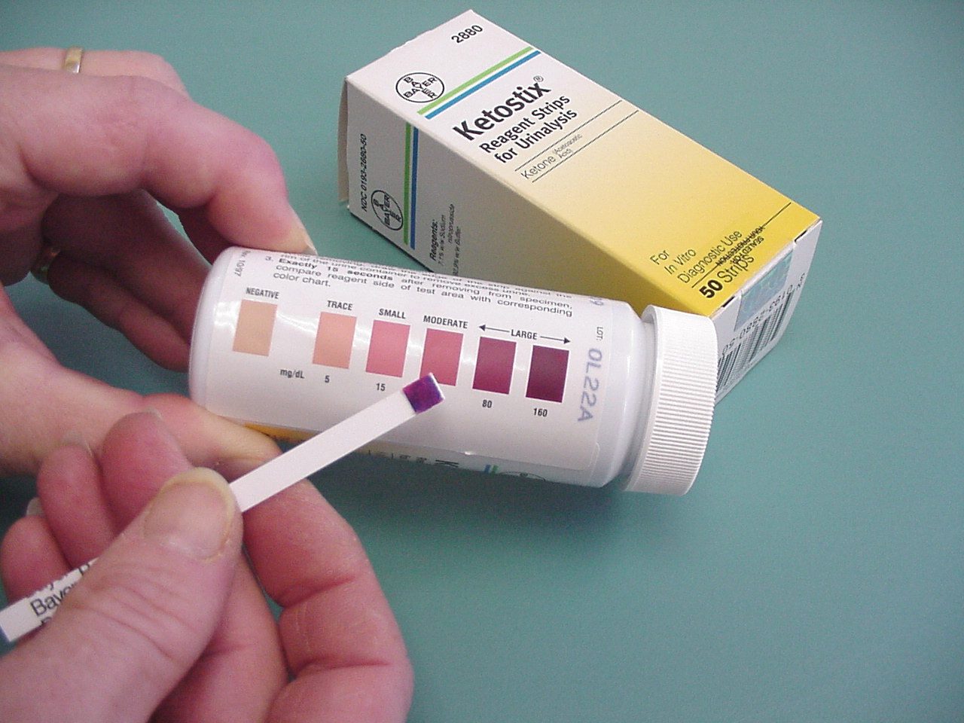

SESSION 5, Hypoglycemia
Objective measure of mastery: patient/family is able to: | Content | Methods | “Spot Checks”
- List common symptoms of hypoglycemia.  - State how to treat a low blood sugar.  - State that 15 gm of CHO is used to treat a low BG. | Hypoglycemia  A. What is hypoglycemia.  1. Sometimes called insulin reaction or low blood sugar.  2. In non-diabetic, hypoglycemia is BG below 60 mg/dl.  3. Most kids with type 2 diabetes never have hypoglycemia.  3. In diabetic child, BG below 70 mg/dl needs to be treated.  B. Causes of hypoglycemia.  1. Too much insulin or diabetes pills.  2. Skipped a meal after taking your medicine.  3. You are sick and cannot eat your usual meals or snacks.  C. Signs and symptoms of mild hypoglycemia.  1. Adrenalin based symptoms – shaky, sweaty, tachycardia, pale, tingling.  2. Brain (CNS) symptoms – confused, hunger, headache, disoriented, moody, sleepy, bad dreams, nightmares, poor coordination, blurry vision.  D. Treating mild hypoglycemia: using the 15/15 rule.  1. Check a BG (if possible) – If not, treat based on symptoms.  2. Give 15 grams of carbohydrate, e.g., 3 sugar cubes, 1 tube cake gel, 6 life savers, ½ cup (4 oz) fruit juice or 4 oz soda pop, 3 glucose tablets. Differentiate a treatment from a treat!  3. Wait 15 minutes for symptom relief.  4. If no improvement, repeat 15 grams CHO.  5. Follow with 15-30 gms CHO with protein if next meal or snack is more than 1 hour away.  6. Write down what you did in your log book.  E. Avoid overtreating hypoglycemia.  F. Preventing hypoglycemia.  1. Know what your blood sugar is.  2. Do not skip meals after taking your medicine.  3. Let important people in your life know about your diabetes.  - Babysitters  - School teachers  - School nurses  - Older brothers and sisters  - Grandparents  - Coaches  - School bus drivers  4. Wear medical ID.  5. Take correct doses of meds and never double a dose. | Patient Manual  Videos  Posters  Test, treat, repeat, eat  Snack ideas (2)  Medical ID | Child/ family are able to answer the following:  (Child) What does an insulin reaction feel like?  (Parent) How will you know if your child is having hypoglycemia?  What causes hypoglycemia?  What would you do if you began to have hypoglycemia in class?  How would you feel about having hypoglycemia with  friends around?  What should your friends know about diabetes?  How much carbohydrate is used to treat hypoglycemia?

Snack Ideas
LowFat
1/2 Sandwich
4 sandwich crackers
1 cup milk
3 cups popcorn
1 ounce chips
2 cookies

Snack Ideas
6 saltine crackers
1 granola bar
3/4 cup cereal

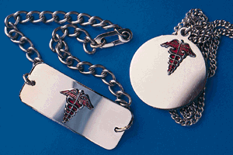
Medical Identification

SESSION 5, Physical Activity: Types; Feet and Water
Objective measure of mastery: patient/family is able to: | Content | Methods | “Spot Checks”
- Show how to decide when to move faster or slower when active. | Physical Activity: types, foot care and hydration  A. Physical activity options.  1. Aerobic means “with air”.  2. Aerobic exercise:  - Uses large muscles.  - Makes heart and lungs stronger.  - Helps control weight.  - Gives you energy.  3. Types:  - Brisk walking.  - Stair climbing.  - Bike riding.  - Karate.  - Jumping rope.  - Jogging and running.  - Dancing.  - Rowing.  - Swimming.  - Rollerblading and skating.  4. Should do 30 minutes at least 4 or 5 times per week.  B. Strength training.  1. Strong muscles help with good balance and posture.  2. Ways to get strong muscles.  - Calisthenics for upper body – pushups, stomach crunches, jumping jacks.  - Hand weights target upper body – lift small dumbbells, sacks of flour or soup cans.  - Weight machines or free weights for strength and muscle toning.  C. Stretching.  1. Muscles are like rubber bands – they can only stretch so far before they tear.  2. Stretching lengthens the muscle safely. This makes the muscle more flexible.  3. Stretch before and after activity.  4. Stretch slowly and steadily – no bouncing.  - Hold the stretch for a count of 20.  - A good stretch may be a little uncomfortable but should never hurt.  D. A personal exercise experiment.  1. Use log book to pick a day when you were especially active.  2. Answer these questions:  - Did you have lower blood sugars on your active day?  - Did you feel more energy on your active day?  - Did you feel stronger on your active day?  - Did you feel better about yourself on your active day?  3. Change will happen slowly – it may take several weeks to see lower blood sugars and more energy.  B. Keep feet healthy.  1. Select sports shoes that fit well.  2. Inspect feet – check for redness, pressure areas.  C. Keep hydrated during activity.  1. Fluid choices: water!  2. Avoid sugary drinks. | Patient Manual  Videos  Poster  An exercise experiment | Child/ family are able to answer the following:  Which aerobic activities do you like?  How will you include strength training and stretching?  What will you watch for when you check your feet?  How will you be sure to drink enough fluids when being active?  What will you drink?

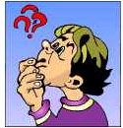

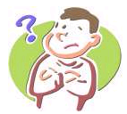
Did you have lower blood
sugars on your active day ?

Did you feel more energy on
your active day ?

Did you feel stronger on your active
day ?

Did you feel better about
yourself on your active
day ?

SESSION 6, Family and School
Objective measure of mastery: patient/family is able to: | Content | Methods | “Spot Checks”
- Discuss strategies for dealing with family and school issues  (not a required competency) | Family Issues  A. Family communication skills.  1. Treat your family with unconditional love and respect.  2. Do not blame others – take responsibility.  3. Share your feelings but try not to lecture.  4. Do not judge the ideas and feelings of others.  5. Let past arguments go.  6. Try to be as honest as possible.  7. Always differentiate between the behavior and the person.  8. Don’t give up.  B. Family meetings can be a good place to share feelings and ideas. Some guidelines for family meetings:  1. Share only your own thoughts and ideas.  2. Not a time to lecture, gripe, or preach.  3. No interrupting – listen until it is your turn.  4. Everyone has a turn.  5. Discuss so everyone understands each other.  6. Resolve all arguments before ending the meeting.  School Issues  A. Who can help? Teacher, nurse, principal, coach, cafeteria workers, bus driver, friends.  B. You may need to teach about diabetes: meters, hypo and hyper, treating hypo, foods.  C. What if they don’t help?  1. Federal laws protect children with diabetes:  - Section 504 of the Rehabilitation Act of 1973.  - Americans with Disabilities Act.  - Individuals with Disabilities Education Act (IDEA).  D. Rights and responsibilities.  1. School’s job:  - Listen to family.  - Offer to make a school plan.  - Learn about diabetes.  - Provide safe place for checking BG.  - Offer good food choices.  - Encourage involvement in school activities.  - Be a partner.  2. Child’s job:  - Decide which people to include in the discussions.  - Make a plan.  - Teach about diabetes.  - Check blood sugars.  - Make good food choices.  - Play sports and join clubs.  - Work hard to get to the next grade.  - Be a partner/ have a partner.  E. Planning for the unexpected.  1. School trips, parties, school bus breaks down.  F. For parents:  - Meet yearly before school starts to meet the “school partners”.  - Teach about diabetes.  - Make a Health Plan.  - Talk to the lunch room about your child’s meal plan.  - Learn about the federal laws.  - Encourage your child to be active and involved.  - Encourage your child to tell friends about diabetes.  - Encourage responsibility, safety.  - Find ways to praise and encourage even for partial successes. | Patient Manual  Videos  Poster | Child/ family are able to answer the following:  How does your family solve problems and  disagreements?  How have you worked with your school?  Who is you “partner” in the school?

SESSION 6, Goal Setting and Problem Solving
Objective measure of mastery: patient/family is able to: | Content | Methods | “Spot Checks”
- Set basic behavior change goals.  (not a required competency) | Goal Setting and Problem Solving  A. What is a goal?  1. A wish or dream  B. Tips for setting goals.  1. Be specific – consider what? when? how long?  2. Measure your success.  3. Make goals challenging but realistic.  4. Choose goals important to YOU.  5. Share your goals with a friend.  C. Some problems to solve.  1. You get home from school and you are really hungry. What do you do?  2. Your friends are going to the movies. You know they will be eating popcorn (with butter) and regular sodas and candy. What do you do?  3. You have 2 birthday parties to go to this weekend. There will be lots of cake and ice cream and sodas. What do you do ?  4. You started a walking program with your friend. You have been walking a mile every day. Now your friend is moving away. What do you do?  5. You are getting really tired of checking your blood sugar. In fact you haven’t checked in about a week. But now you have a clinic visit tomorrow. You have heard that some kids just right numbers in their log books. What do you do?  6. You have finished your diabetes classes, but you want to learn a few more things about diabetes. What do you do? | Patient Manual  Videos  Poster  Use worksheet in manual to set a goal | Child/ family are able to answer the following:  What information will help you make safe decisions about self care issues?

SESSION 7, Teen Issues
Objective measure of mastery: patient/family is able to: | Content | Methods | “Spot Checks”
- Discuss typical teen issues.  (not a required competency) | A. Making Choices.  1. Living with diabetes is filled with challenges.  2. Diabetes affects everything you do.  3. Everyday is filled with choices and you might begin to feel fed up.  B. Dealing with Stress.  1. Identify things that are stressful.  2. How does it feel to be stressed?  3. What do you do to feel better?  4. How does stress affect diabetes?  - Having stress and feeling upset can raise BG.  - Feeling stressed is distracting.  - Some people stop taking care of diabetes.  - We can’t avoid stress – but we can choose how to react to it.  - 2 examples: Shondra and Isaac.  C. Self Esteem.  1. How do you feel about you?  2. Who is on your support team?  3. Are you making progress towards your goals?  4. Do you blame diabetes for your problems?  5. How to know if you are feeling good. You…  - feel happy and content most of the time.  - enjoy activities with friends and family.  - feel that people respect you – not pity you.  - feel you are good at what you do.  - can talk comfortably about diabetes with others.  - don’t dwell on diabetes.  - don’t use diabetes as an excuse for your actions.  - taking care of diabetes feels routine.  D. Adolescence, hormones and diabetes.  1. Pubertal hormones can make you feel stressed or moody.  2. Fluctuating blood sugars can do that also.  3. How will you know if your moods are due to your diabetes? Check a BG!  4. Girls may notice blood sugar changes during the menstrual cycle – typically BG will rise a week or so before their periods  E. Making Decisions.  1. STAR: Stop/ Think/ Act/ Reflect  - STOP: What was the problem?  - THINK: What are the choices? What are the good points? What are the bad points?  - ACT: What are you going to do? What did you do?  - REFLECT: What happened? Would you do it that way again?  2. Some examples.  - Monica is having trouble with the math problems in class today. She really just wants a break. She heard of some kids with diabetes faking a low blood sugar to get out of class. What should she do?  - Tony has not been following his meal plan lately. He also quit doing blood sugar checks. He has a clinic visit and know his diabetes team will not be happy with him. What should Tony do?  - Mikah is 14. She is at her friend Dara’s house with some other friends. Dara’s parents aren’t home. Dara finds some vodka and starts passing it around. The others join in and the bottle comes to Mikah. What should Mika do?  3. How to make quick decisions.  - Know your goals.  - Know your values and your family’s values.  - Trust your goals and values.  - Gather as many facts as you can.  - Take your time to decide.  - Ask friends and family you trust for help.  - Make the choice for YOU, not for others.  F. Tobacco and Drugs.  1. Make your choice based on some facts:  - Under-age smoking is illegal.  - Drug use is illegal.  - Tobacco in any form is linked to cancer and other diseases.  - Tobacco and diabetes is a deadly pair. Both narrow blood vessels and can slow blood to the brain, heart, and other body parts.  - Drugs take you away from your goals; they can mess up BG (up or down) and will mess up your choices and goals.  G. Alcohol.  1. Make your choice based on some facts:  - Under-age drinking is illegal.  - Alcohol and driving do not mix.  - Alcohol is full of calories – and the mixers are full of calories.  - Alcohol blocks your body’s ability to raise blood sugar after it has been low. Alcohol works against your medicines also.  2. Drinking safely and responsibly if you are old enough.  - Wear a medical ID.  - Tell friends about diabetes – hypo can look like intoxication.  - Don’t skip meals.  - Don’t skip medicines.  - Limit drinks to 2 per day.  - Mix drinks with diet sodas or water.  - Know your blood sugar – especially before sleeping.  - Don’t ever drink and drive.  E. Relationships and Pregnancy.  1. How to tell your date you have diabetes.  2. How to deal with the “food patrol”.  3. Decisions about sex.  - Be sure you are ready.  - Be sure you are protected (from pregnancy and disease).  4. Pregnancy  - Serious for women with diabetes – must be carefully planned for the best outcomes to mother and baby.  - In the TODAY trial, the diabetes team MUST KNOW IF YOU THINK YOU ARE PREGNANT – study medications could harm the fetus.  F. Communicating with parents and other forms of intelligent life.  1. Teens and adults have different views of the world  2. Our comments are a mix of facts and feelings  - Great communication includes both facts and feelings.  - Some examples: What are the facts and the feelings in these statements?  “That Mr. Pacheco is the worst teacher in the whole school . He gave me a D on the test!”  Rubia didn’t check her BG much last week. Her doctor says, “Why didn’t you check at supper last week?” | Patient Manual  Videos  Poster | Adolescent is able to answer the following?  What things are stressful in your life?  How do you “de-  stress“?  How do you make decisions?  Have you ever made a bad decision? What did you learn from it?  How hard is it to avoid drugs, alcohol, and tobacco?  What plans do you have to be protected from sexually transmitted diseases?

