Anemia
What is Anemia?
It is the job of red blood cells to carry oxygen to the cells and tissues in your body. Anemia is when you/ your child’s red blood cells are low and can’t bring enough oxygen to the rest of your body.
There are many different kinds of anemia. In TODAY, we are mostly concerned about iron deficiency anemia, because some of the medicine we use in the study can make this kind of anemia worse. To make sure your child is healthy while he or she is in TODAY, we check for iron-deficiency and other kinds of anemia during regular blood tests.
If your child had anemia during Run-in, he or she would not have been able to join TODAY until it was treated. If your child develops anemia after Randomization, we might need to change the dose of the study medicine, or stop it altogether until the anemia resolves.

What Causes Anemia?
Anemia affects hemoglobin, a substance in your red blood cells that help them carry oxygen to all parts of the body. In order to make hemoglobin, your body needs iron. If a person has iron-deficiency anemia, he or she does not have enough iron to make the right amount of hemoglobin. When that happens, your red blood cells can’t bring enough oxygen to your body.

Anemia can also be caused by certain medicines. It can also be caused by blood loss, which can happen to girls or women who have heavy periods. Because of this, it is important to tell the study nurse or doctor what medicines your child takes, and if he or she has times of heavy bleeding.

How Can I Prevent Anemia?
A great way to prevent iron-deficiency anemia is to make sure you get the right amount of iron in your diet.
Girls, ages 11 and older, need about 14-18 mg of iron daily.
Boys, ages 11 and older, need about 12-14 mg of iron daily.
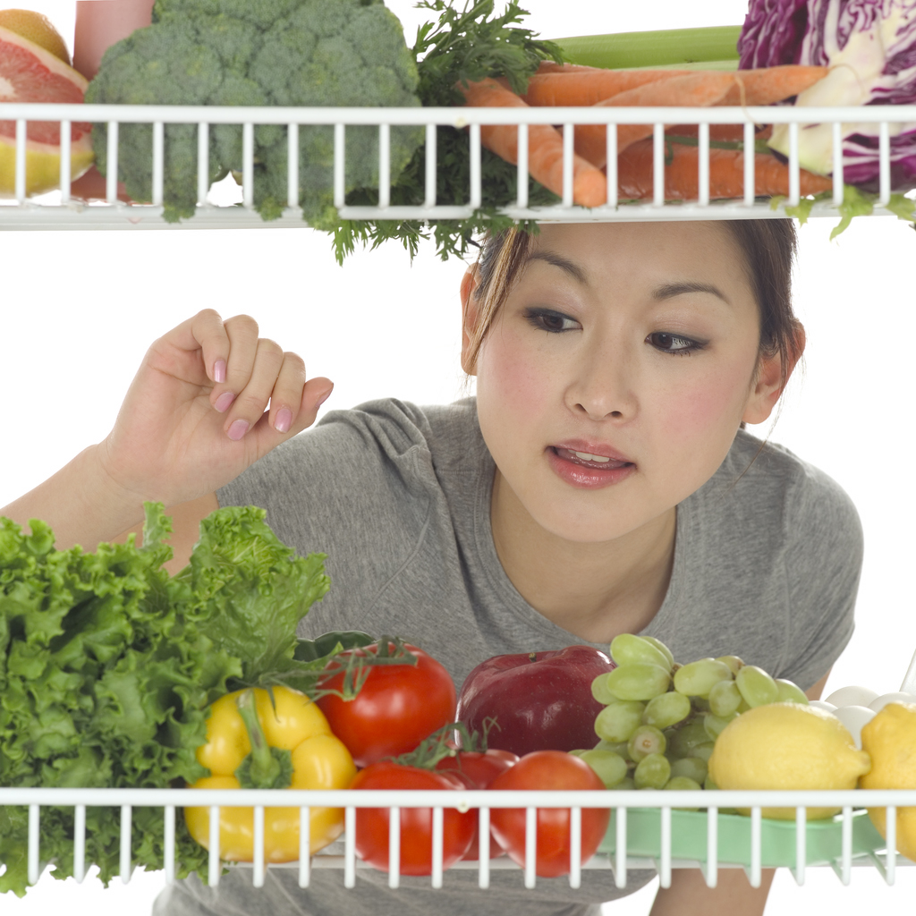
Some foods that have a lot of iron are:
• Meats Three ounces of beef, pork
and lamb have 2.3-3.0 mg iron.
• Fish
• Poultry
• Spinach, kale and other dark green,
leafy vegetables. For ex., ½ cup green
beans has 0.8 mg. iron, and ½ cup cooked
spinach contains 2.5 mg iron.
• Peanut butter
• Eggs
• Lima, Kidney and Pinto Beans For. ex., ½ cup cooked pinto beans contains 1.8 mg iron.
• Iron enriched cereals, breads and pasta For ex., 1 slice of whole wheat bread has 0.9 mg iron.

Help Your Body Use the Iron in Your Foods!
To make the most of the iron in your foods, eat vegetables and fruits that are high in vitamin C – like oranges, broccoli, strawberries and cantaloupe – when you eat iron-rich foods.

Your diabetes educator can teach you how to read food labels to look for food that is high in iron and vitamin C. These labels list the amount of iron as a percentage of the amount a person should eat every day.

For example, 1 cup of this cereal listed below has 45% of the iron most people need each day!

NUTRITION FACTS
Serving Size 1 cup (29g/1.0 oz.)
Servings Per Container About 31 ___________________________________
Amount Per Serving Cereal
Calories 110
Calories from Fat 0 ___________________________________
% Daily Value
Total Fat 0g 0%

Cholesterol 0mg 0%

Sodium 210 mg 9%
Potassium 35mg 1%
Total Carbohydrate 25g 8%
Protein 2g

Vitamin A 10%
Vitamin C 10%
Calcium 0%
Iron 45%

How is Anemia Treated?
To prevent iron-deficiency anemia, eat foods that have a lot of iron, along with foods that are high in vitamin C.

In some cases, a doctor or nurse practitioner may prescribe iron supplements, usually for 2 to 3 months. We will be checking improvement in anemia with routine blood tests at study appointments. Your child should take these supplements with orange juice to help the body absorb them better. Because they can upset a person’s stomach, your child should take the pills with food. Iron supplements can also cause constipation or darker bowel movements. If your child takes iron supplements, tell your healthcare provider if he or she gets an upset stomach or constipation.

